Java Lab Assignment 3

By:
Vaibhav Jaiswal
PRN = 17070122071
CS – 4
SY CSE
Batch OF 2017-2021

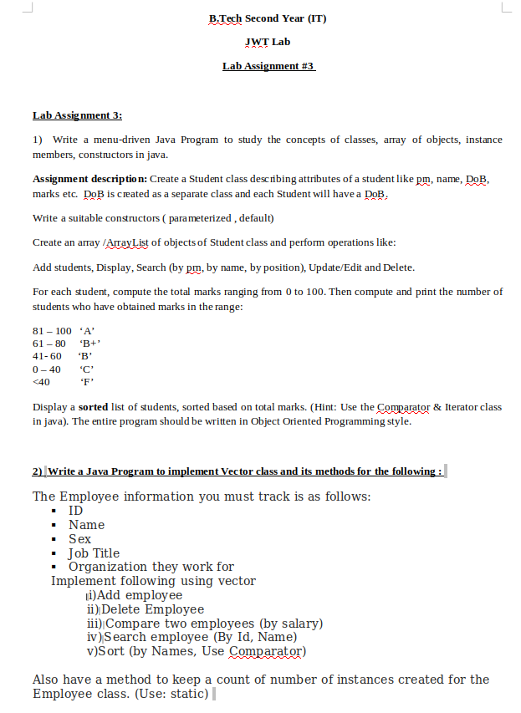

CODE :

import java.util.*;
import java.util.ArrayList;
import java.util.Iterator;

class DoB{
int year ;
int month ;
int date ;

DoB(){
this.year = 0 ;
this.month = 0 ;
this.date = 0 ;
}
DoB(int year , int month , int date){
this.year = year ;
this.month = month ;
this.date = date ;
}

public String toString(){ // Modified toString to Print DoB in proper form

return (date+" / "+month+" / "+year);
}

public int getDate(){
return date ;
}

public int getMonth(){
return month ;
}

public int getYear(){
return year ;
}
}

class Student{

long prn ;
String name ;
DoB DateOfBirth ;
double marks ;
char grade ;

Student(){
this.prn = 0 ;
this.name = "";
this.DateOfBirth = new DoB() ;
this.marks = -1 ;
grade = ' ' ;
}

Student(long prn ,String name , double marks ,int d , int m , int y){
this.prn = prn ;
this.name = name ;
this.DateOfBirth = new DoB(y , m , d) ;
this.marks = marks ;

if (marks >= 80) // Grade Assignment
grade = 'A' ;
else if (marks >= 60)
grade = 'B' ;
else if (marks >= 40)
grade = 'C' ;
else
grade = 'D' ;
}

public String toString(){ // Modified toString to Print Student Details

return ("\nName : "+name+"\nPRN : "+prn + "\nDoB : "+DateOfBirth.toString()+"\nMarks : "+marks+"\nGrade : "+grade);
}

public long getPrn(){
return this.prn ;
}

static void printAll(ArrayList<Student> stu){ // Printing all the Student Enteries in Student ArrayList
for (int k = 0 ; k < stu.size() ; k++){
System.out.println("***************************************************************************************");
System.out.println("Student - "+(k+1)+"\n"+stu.get(k));
System.out.println("***************************************************************************************");
} ;
}

public static int searchByPrn(ArrayList<Student> stu , long prn){

boolean found = false ;
int indx = 0 ;
for(Student temp: stu){ // Using Enhanced For Loop To Traverse the ArrayList

if(temp.prn == prn){
found = true ;
break ;
}
indx++ ;
}

if(found == true)
return indx ;

else return -1 ;
}

public static int searchByName(ArrayList<Student> stu , String name){

boolean found = false ;
int indx = 0 ;

Iterator itr = stu.iterator() ; // Using Iterators to traverse over Student ArrayList

while(itr.hasNext()){
Student temp = (Student)itr.next() ;

if(temp.name.compareTo(name) == 0 ){

found = true ;
break ;
}
indx++ ;
}

if(found == true)
return indx ;

else return -1 ;

}

public static int searchByPos(ArrayList<Student> stu , int pos){
int indx = 0 ;

Iterator itr = stu.iterator() ;

if(pos <= stu.size()){

while(itr.hasNext()){
itr.next() ;

if(pos-1 == indx){

return indx ;
}
indx++ ;
}
}

return -1 ;
}

public static void updateStud(ArrayList<Student> stu , int pos ){

Student temp = (Student)stu.get(pos) ;

Scanner ip = new Scanner(System.in) ;

System.out.println("Current Details Of Student") ;
System.out.println(temp) ;
System.out.println("Enter which attribute do you want to change : ") ;
System.out.println("1. PRN ");
System.out.println("2. Name ");
System.out.println("3. DoB ");
System.out.println("4. Marks ");
System.out.println("Your Choice:");

int date ,month , year ;
date = temp.DateOfBirth.getDate() ;
month = temp.DateOfBirth.getMonth() ;
year = temp.DateOfBirth.getYear() ;
int choice = ip.nextInt() ;

switch(choice){
case 1:
temp.prn = ip.nextLong() ;
break ;

case 2:
temp.name = ip.nextLine() ;
break ;

case 3 :
{
System.out.println("Update which parameter.\n1.date\n2.month\n3.year\nYour choice:");

int dobchoice = ip.nextInt() ;

switch(dobchoice){
case 1:
System.out.println("Enter Date - ") ;
date = ip.nextInt() ;
break ;

case 2 :
System.out.println("Enter Month - ") ;
month = ip.nextInt() ;
break ;

case 3 :
System.out.println("Enter Year - ") ;
year = ip.nextInt() ;
break ;
}

break ;

}

case 4:
System.out.println("Enter Marks - ");
temp.marks = ip.nextDouble() ;
break ;

}

stu.set(pos, new Student(temp.prn , temp.name , temp.marks , date , month , year)) ;
System.out.println("Updation Successfull") ;

}
}

class SortByMarks implements Comparator<Student>{

public int compare(Student a , Student b){

int x ;
x = (a.marks>b.marks)?-1:1 ;
x = (a.marks == b.marks)?0:x ;
return x ;
}
}

class Driver1{

public static void main(String[] args) {
ArrayList<Student> stu = new ArrayList<Student>();

Scanner ip = new Scanner(System.in);
boolean exit = false ;

do{
System.out.println("\nOperations :");
System.out.println("1.Enter Students");
System.out.println("2.Display Students");
System.out.println("3.Search by PRN ");
System.out.println("4.Search by Name");
System.out.println("5.Search by Pos");
System.out.println("6.Sort by Marks");
System.out.println("7.Update/Edit details of Student");
System.out.println("8.Delete Student ");
System.out.println("9.Exit");
System.out.println("Enter Choice :");

int choice = ip.nextInt() ;

switch(choice){

case 1:

/* Entering Details of Student*/
char another = 'y' ;
System.out.println("Enter The Details of Students : ");
int i = 0 ;
while(another =='y'){
System.out.println("Student - "+(++i)) ;
ip.nextLine();
System.out.println("Name :");
String name = ip.nextLine() ;
System.out.println("PRN :");
long prn = ip.nextLong();
System.out.println("DOB (d m y with spaces btw them) :");
int d = ip.nextInt() ;
int m = ip.nextInt() ;
int y = ip.nextInt() ;

System.out.println("Total Marks :");
double marks = ip.nextDouble() ;

stu.add(new Student(prn , name , marks , d , m , y)) ;
System.out.println("Do you want to get another Record : ");
ip.nextLine();
another = ip.next().charAt(0) ;
}

break ;

case 2:
/* Displaying The Whole */
Student.printAll(stu) ;
break ;

case 3:
/* Search By PRN */
long pr ;
int indx = 0 ;

System.out.println("Enter the Prn To Search");
pr = ip.nextLong() ;
indx = Student.searchByPrn(stu , pr) ;

if (indx != -1)
{
System.out.println("Student Found with Entered PRN :\n Details Of student ");
System.out.println(stu.get(indx)) ;
}

else{
System.out.println("PRN not found ");
}
break ;

case 4:
{
/*Search by name*/
String name ;

System.out.println("Enter the Name to Search");
ip.nextLine() ;
name = ip.nextLine() ;

int indxname = Student.searchByName(stu , name) ;

if (indxname != -1)
{
System.out.println("Student Found with Entered Name :\n Details Of student ");
System.out.println(stu.get(indxname)) ;
}

else{
System.out.println("Entered Student not found ");
}
break ;
}

case 5:
{
/* Search by Pos */
int pos ;

System.out.println("Enter position which you want to search");
pos = ip.nextInt() ;

int indxpos = Student.searchByPos(stu , pos) ;
if (indxpos != -1)
{
System.out.println("Student Found at entered pos :\n Details Of student ");
System.out.println(stu.get(indxpos)) ;
}

else{
System.out.println("No student found at Entered position");
}
break ;
}

case 6:
/*Sort on the Basis of Marks*/
Collections.sort(stu , new SortByMarks());
System.out.println("SOrting on Basis of Marks Done : \n ");
Student.printAll(stu);
break ;

case 7:
/*Update Student Entry*/
Student.printAll(stu) ;
System.out.println("Enter the Index of which Student Entry to update :") ;
int upIndx = ip.nextInt() ; // Index which to Update

Student.updateStud(stu , upIndx-1) ;
ip.nextLine() ;
break ;

case 8:
/*Delete Student Entry*/
Student.printAll(stu) ;
System.out.println("Enter the Index of which Student Entry to Delete :") ;
int delIndx = ip.nextInt() ; // Index which to delete

stu.remove(delIndx-1) ;
break ;

case 9:
exit = true ;
break ;

}
}while(!exit);

ip.close();
}
}

OUTPUT :

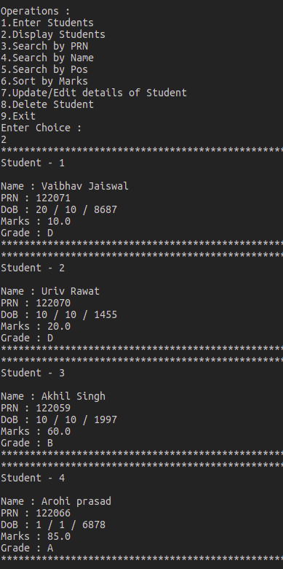

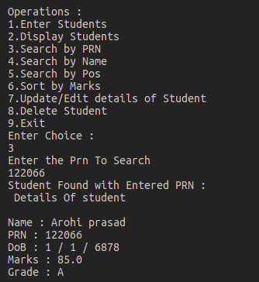

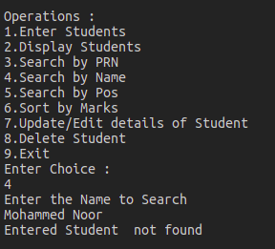

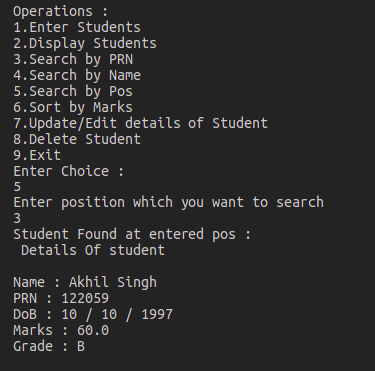

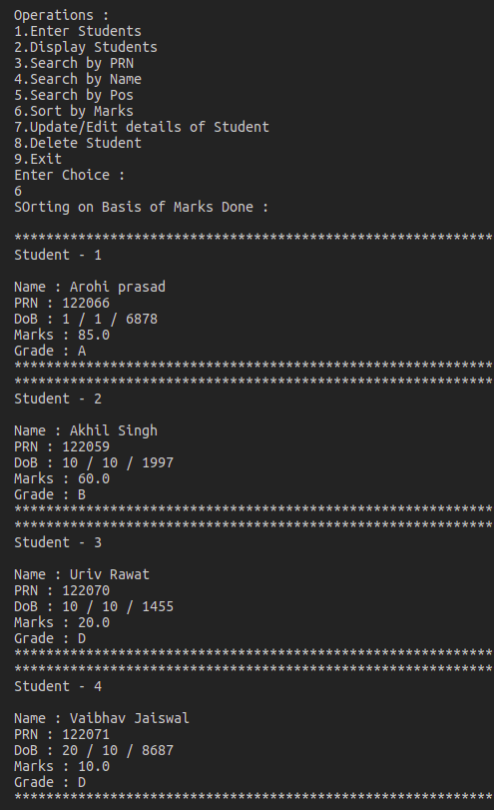

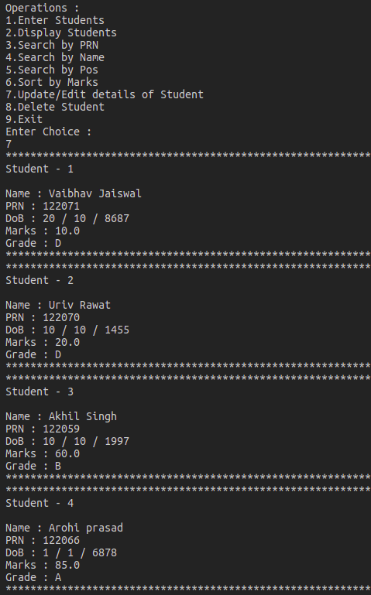

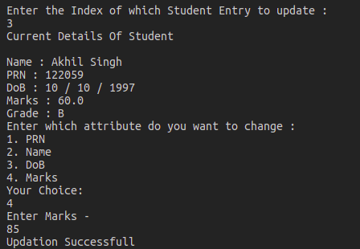

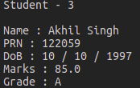

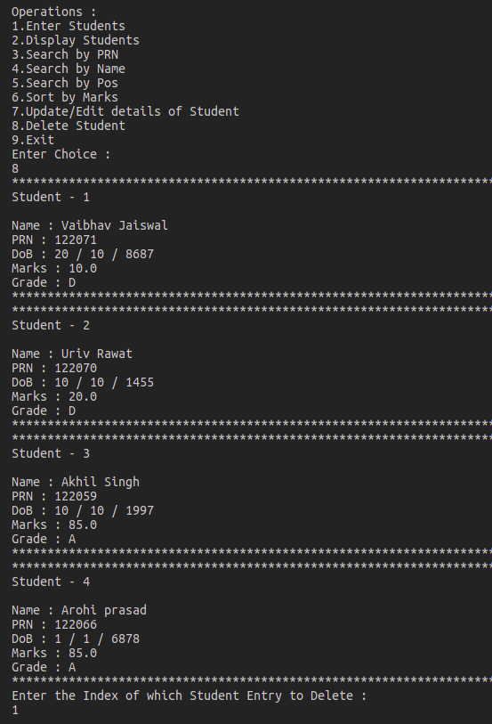

After Deletiong List

